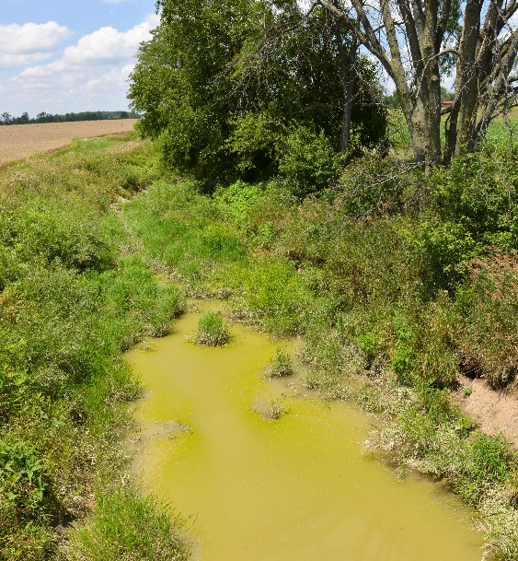
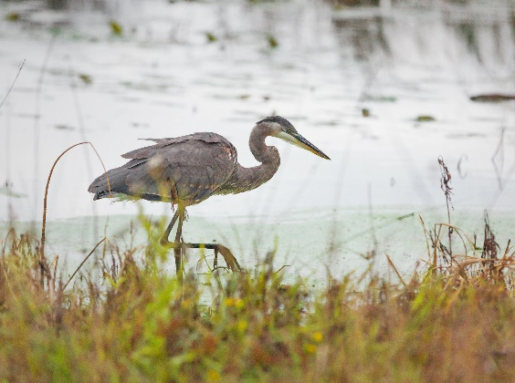
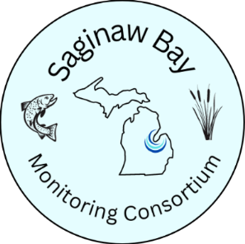
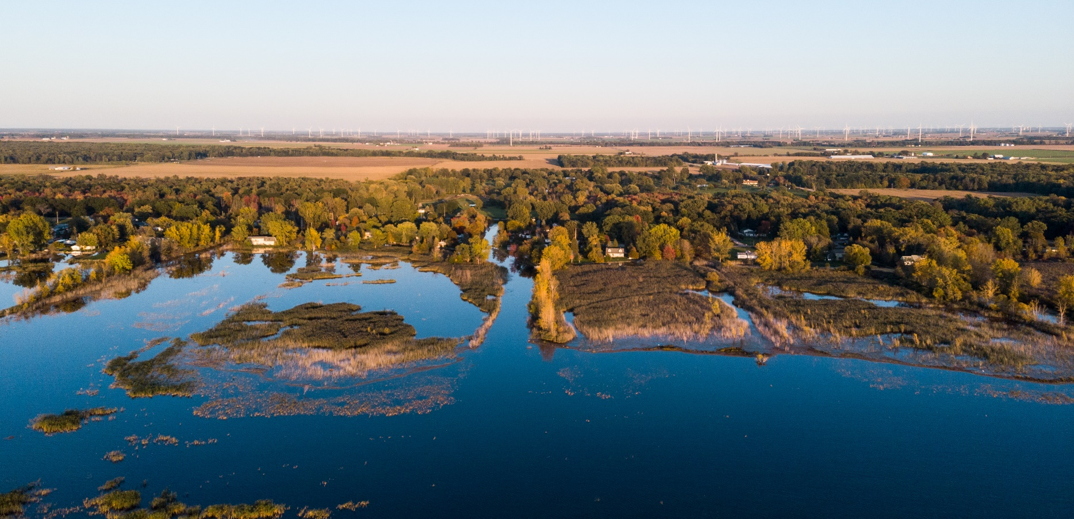
111
Explore the StoryMap and online dashboard!
The Challenge
Water is essential to life. It is also a dynamic resource, highly responsive to changes in weather patterns and land uses. Understanding the condition of a complex system like the Saginaw Bay Watershed, the largest in Michigan, requires robust, comprehensive data that captures trends in water quality over time.
Unfortunately, monitoring efforts for Saginaw Bay to date have been neither long-term nor coordinated, and the data that exists is not easily accessible. We know that water quality in Saginaw Bay is degraded—including elevated levels of nutrients (phosphorus and nitrogen)—but we lack a detailed, location-specific understanding of the management implications.
Saginaw Bay And Its Watershed
A consortium of partners has come together to develop a coordinated monitoring framework and new ecosystem models for the Saginaw Bay Watershed to fill these data gaps and inform:
- Actions to reduce significant environmental damage (i.e. Beneficial Use Impairments, as identified by the International Joint Commission) in the Saginaw Bay “Area of Concern.”
- Targets for reducing nutrient levels in Saginaw Bay, under Annex 4 of the Great Lakes Water Quality Agreement.
- Watershed restoration and management decision-making by watershed groups and municipal stormwater managers.
This effort builds on a successful framework developed for Western Lake Erie by Heidelberg University. Monitoring data is publicly available through an online dashboard so that all stakeholders can understand just how water quality is changing here—over time and at scale—and better align complementary efforts.
Project Status
The coordinating team, in consultation with an advisory committee of academic, agency, and local experts, has completed planning and fundraising to cover monitoring activities through 2026 and began installing new stream gauges in fall 2022. In 2023, monitoring began, which included adding 11 new stream locations and five new bay locations. Continuing activities include collecting water samples in the tributaries and bay and developing the data dashboard. We are also building partnerships with local organizations and will adaptively manage the initiative to best serve local communities and regional entities, address the uncertainties of climate change impacts, and ensure financial sustainability for the coming decade.
© Jason Whalen/Fauna Creative
The Saginaw Bay
Monitoring Consortium:
Addressing regional water quality information needs


Scan the QR code or visit https://www.svsu.edu/sbesi/research/saginawbaymonitoringconsortium/

© Randall L. Schieber

© Jason Whalen/Fauna Creative

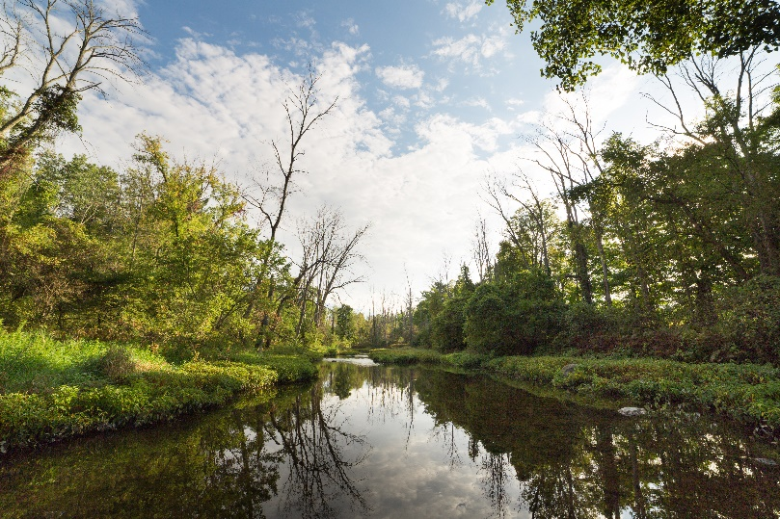
Monitoring Locations
Currently, there are a total of 18 stream gauges and 10 bay monitoring locations.

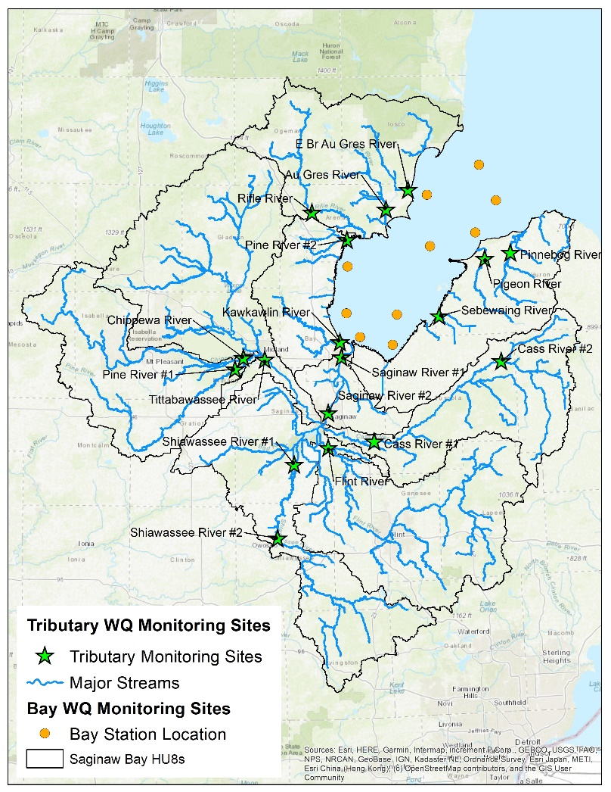

© Jason Whalen/Fauna Creative

Priority Metrics
Informed by interested parties and water quality regulators, we have identified priority metrics for monitoring tributaries and the nearshore area of Saginaw Bay.

 | Tributary Monitoring Sites | Bay Monitoring Sites
Stressor Metrics | Total Phosphorus (TP)  Dissolved Reactive Phosphorus (DRP)  Nitrate (NO₃-)  Nitrite (NO₂-)  Ammonium (NH₄+)  Total Suspended Solids (TSS)  Discharge (for loading) | Total Phosphorus (TP)  Dissolved Reactive Phosphorus (DRP)  Nitrate (NO₃-)  Nitrite (NO₂-)  Ammonium (NH₄+)  Total Suspended Solids (TSS)
Response Metrics | Turbidity  Dissolved Oxygen (DO) | Harmful Algal Blooms Chlorophyll  Dissolved Oxygen (DO)  Turbidity (Secchi)

Central Michigan University:
Rod Lammers, Assistant Professor, School of Engineering and Technology
Saginaw Valley State University:
David Karpovich, Professor of Chemistry and Director, Saginaw Bay Environmental Science Institute
Rebecca Bowen, Water Quality Analyst/Lab Technician
NOAA, Great Lakes Environmental Research Laboratory:
Craig Stow, Senior Research Scientist
LimnoTech:
John Bratton, Senior Scientist
Saginaw Chippewa Indian Tribe:
Alex Robins, Water Quality Specialist
Michigan Department of Agriculture and Rural Development
Kelcie Sweeny, Environmental Monitoring Specialist
US Environmental Protection Agency:
Trent Henry, Life Scientist
US Geological Survey:
Sherry Martin, Physical Scientist
Michigan Department of Environment, Great Lakes, and Energy:
Bretton Joldersma, Lake Huron Coordinator
Samantha Todaro, Area of Concern Coordinator
Marcy Knoll-Wilmes, Water Resources Division Lake Michigan Unit Supervisor
The Nature Conservancy:
Rebecca Hagerman, Conservation Associate
Coordinating Team | Contact: David Karpovich, dsk@svsu.edu
The members of the Saginaw Bay Monitoring Consortium acknowledge the generous support of the project by the following: Environmental Protection Agency’s Great Lakes Restoration Initiative; Michigan Department of Environment, Great Lakes, and Energy; The Cook Family Foundation; The Jury Foundation.

